**COMPUTER ARCHITECTURE LAB**

**LAB TASK 2**

**Class ID:** 113035 **Name:** Abrar ul Hassan **Student ID:** 10970

**Task 1:**

#define ledPin 12 // choose the pin for the LED

#define switchPin 10 // choose the input pin (for a pushbutton)

int val = 0;

void setup()

{

  pinMode(ledPin, OUTPUT);

  pinMode(switchPin, INPUT_PULLUP);

**Serial**.begin(9600);

}

void loop()

{

  val = digitalRead(switchPin);

**Serial**.print(val);

  if (val == HIGH)

  {

    digitalWrite(ledPin, HIGH);

  } else {

    digitalWrite(ledPin, LOW);

  }

  delay(1000);

}

**Task 2:**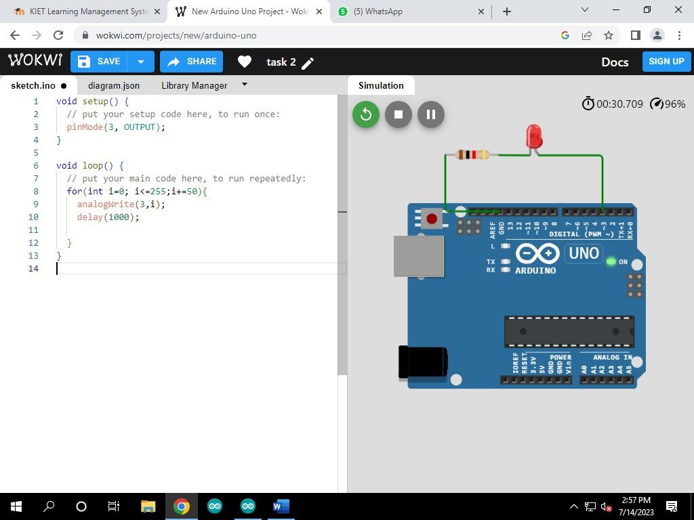

**Task 3:**

#define pwmPin 3

#define inputPin1 12

#define inputPin2 13

void setup() {

  // put your setup code here, to run once:

  pinMode(pwmPin, OUTPUT);

  pinMode(inputPin1,INPUT);

  pinMode(inputPin2, INPUT);

}

void loop() {

  // put your main code here, to run repeatedly:

  int readPin1= digitalRead(inputPin1);

  int readPin2= digitalRead(inputPin2);

  if(readPin1==LOW && readPin2==LOW){

    analogWrite(3,0);

  }

  else if(readPin1==HIGH && readPin2==LOW){

    analogWrite(3,130);

  }

  else if(readPin1==LOW && readPin2==HIGH){

    analogWrite(3,200);

  }

  else{

    analogWrite(3,255);

  }

}

